

**Nagios** is the most popular, open source, powerful monitoring system. It enables organizations to identify and resolve IT infrastructure problems before they affect critical business processes. Nagios has the capability of monitoring application, services, entire IT infrastructure.

This is Part-1 of complete article **How to Setup Nagios Monitoring Server with NagiosQL on CentOS/RHEL 7/6**, In this part, you will find the steps to setup Nagios Monitoring Server on CentOS, Redhat, and Fedora systems.

**Step 1 – Install Required Packages**

We assume that you have fresh installed CentOS, Red Hat or Fedora systems, So our first requirement is to install Apache and PHP first. Use the following commands to complete it.

**Install Packages:**

# yum install httpd php php-cli gcc glibc glibc-common gd gd-devel net-snmp

**Start Services:**

# service httpd start

**Step 2 – Setup User Accounts**

Now create a new nagios user account and setup a password to this account

# useradd nagios

# passwd nagios

Now create a groud for nagios setup “nagcmd” and add nagios user to this group. Also add nagios user in apache group.

# groupadd nagcmd

# usermod -a -G nagcmd nagios

# usermod -a -G nagcmd apache

**Step 3 – Install Nagios Core Service**

After installing required dependencies and adding user accounts. Let’s start with Nagios core installation. Download latest Nagios core service from the official site.

# cd /opt/

# wget https://assets.nagios.com/downloads/nagioscore/releases/nagios-4.3.4.tar.gz

# tar xzf nagios-4.3.4.tar.gz

# cd nagios-4.3.4

# ./configure --with-command-group=nagcmd

# make all

# make install

# make install-init

# make install-config

# make install-commandmode

Now use below command to setup apache configuration for Nagios installation.

# make install-webconf

**Step 4 – Configure Apache Authentication**

We need to setup apache authentication for user nagiosadmin. Do not change this username. else you would required more changes in configuration.

# htpasswd -c /usr/local/nagios/etc/htpasswd.users nagiosadmin

Now restart Apache service to make the new settings take effect.

# service httpd restart

**Step 5 – Install Nagios Plugins**

After installing and configuring Nagios core service, Download latest nagios-plugins source and install using following commands.

# cd /opt

# wget http://nagios-plugins.org/download/nagios-plugins-2.2.1.tar.gz

# tar xzf nagios-plugins-2.2.1.tar.gz

# cd nagios-plugins-2.2.1

Now compile and install nagios plugins

# ./configure --with-nagios-user=nagios --with-nagios-group=nagios

# make

# make install

**Step 6 – Verify and Start Nagios**

First, verify the Nagios configuration file using the following command.

# /usr/local/nagios/bin/nagios -v /usr/local/nagios/etc/nagios.cfg

If there are not error, lets start the Nagios serivce

# service nagios start

# chkconfig --add nagios

# chkconfig nagios on

**Step 7 – Access Nagios in Web Browser**

Nagios creates its own apache configuration file **/etc/httpd/conf.d/nagios.conf**. There are no need to make any changes to it. Simply open below url in browser.  
**[change domain name with your domain or ip]**

http://test.tecadmin.net/nagios/

**Prompting for Apache Authentication Password –**

[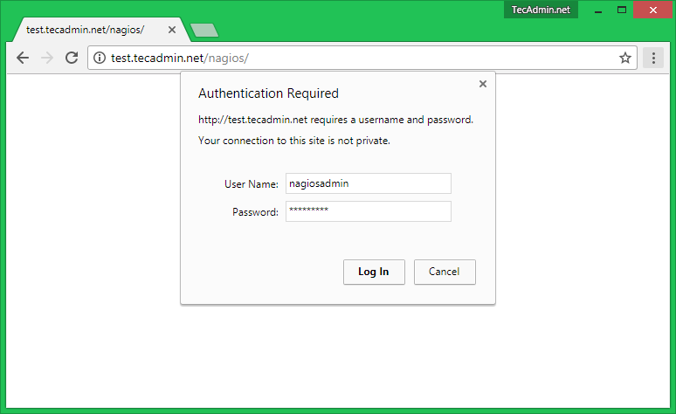](https://tecadmin.net/wp-content/uploads/2015/01/install-nagios-1.png)

**Nagios After login screen –**

[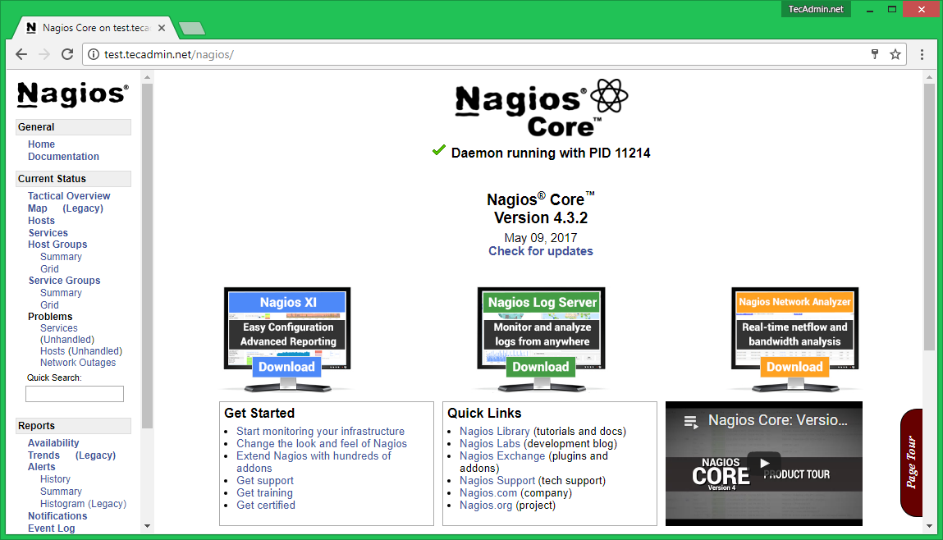](https://tecadmin.net/wp-content/uploads/2015/01/install-nagios-2.png)

Now you have successfully installed and configured Nagios core service in your system.

NRPE

client (nagios)

yum install epel-release

yum install nrpe nagios-plugins-all openssl -y

vi /etc/nagios/nrpe.cfg

allowed_hosts=127.0.0.1,serverip

:wq!

systemctl start nrpe

chkconfig nrpe on

nagios Sever

==========

vim /usr/local/nagios/etc/nagios.cfg

un comment the ( cfg_dir=/usr/local/nagios/etc/servers )

mkdir  /usr/local/nagios/etc/servers

cd /user/-----/servers

vim client.cfg

define host{

use               linux-server

host_name         hostname

alias             Node1

address           ip

max_check_attempts 5

check_period       24x7

notification_interval 30

notification_period 24x7

}

:wq!

systemctl restart nagios

check in we browser

vi /usr/local/nagios/etc/servers/client.cfg

define service {

        use

        host_name               generic-service

        service_description     SSH

        check_command           check_ssh

        notifications_enabled   0

        }

:wq!

systemctl restart nagios